OS Assignment 1

1. b) c)

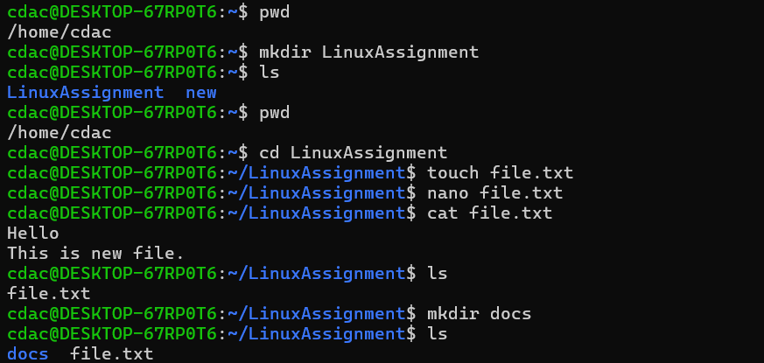

d)

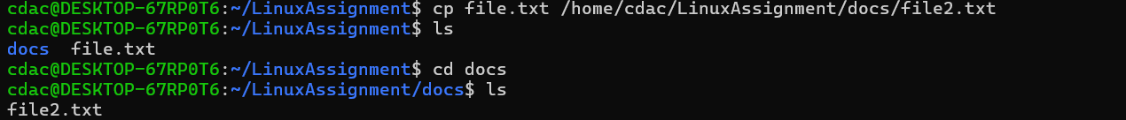

e)

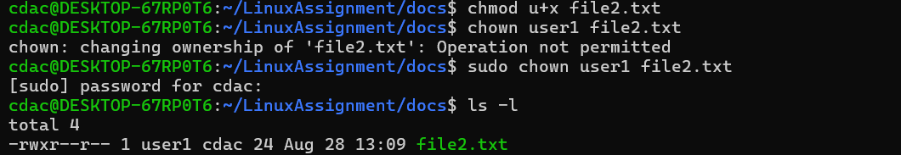

f)



g) h)

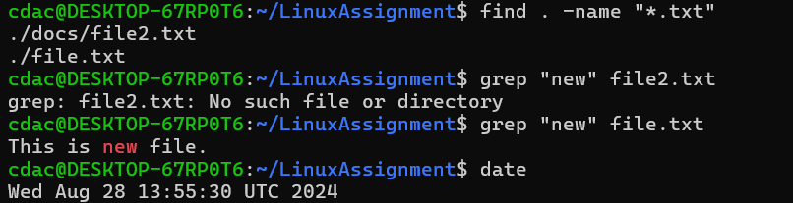

i)

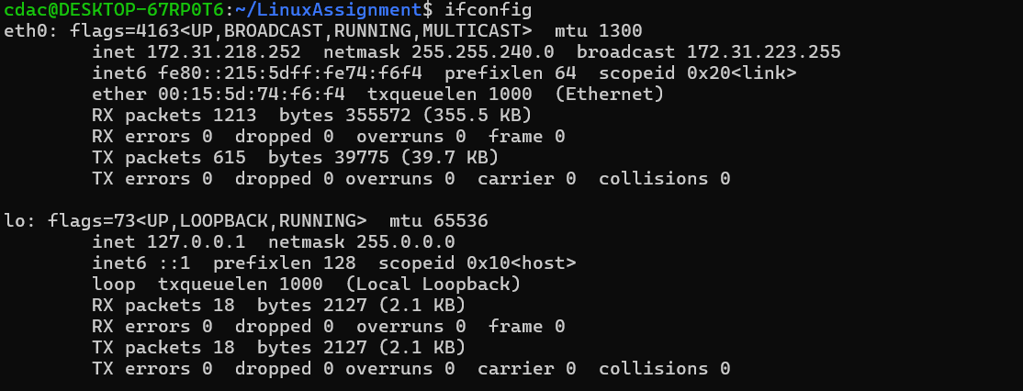

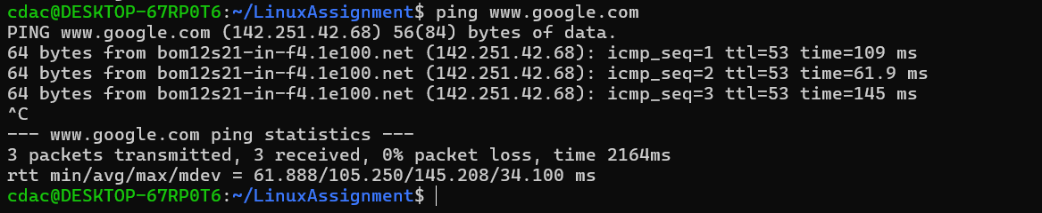

j)



k)

Problem 2

a)

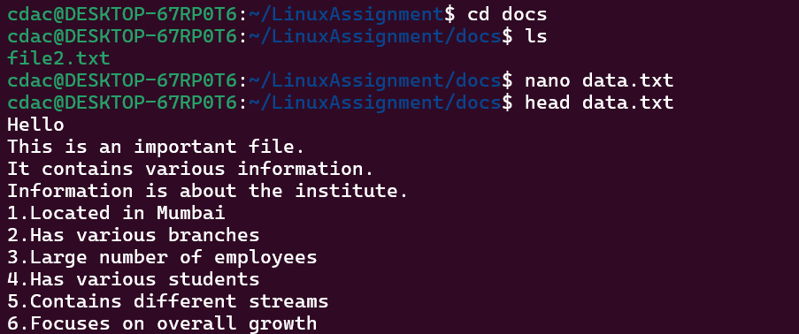

b)

c)

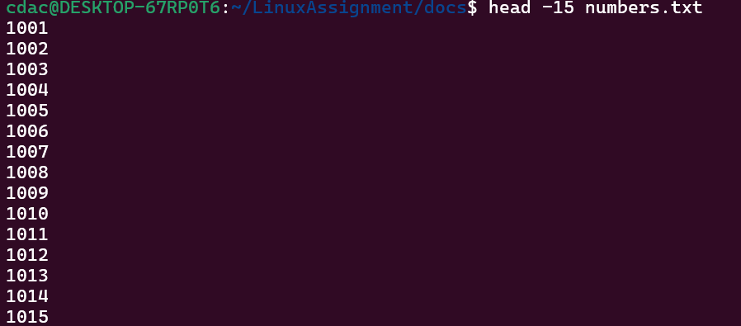

d)



e)

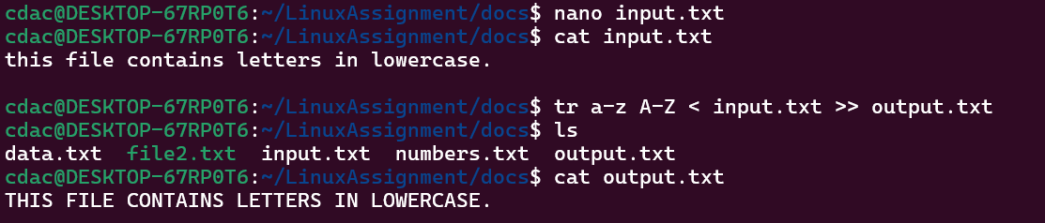

f)

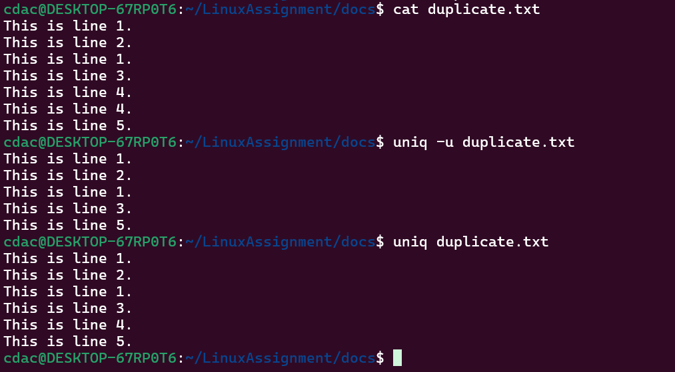

g)

